Age UK Westminster Payroll

# Introduction

This document explains the Age UK Westminster monthly payroll procedure.

# What is Payroll?

Payroll is the list of employees and their associated monthly compensation. Compensation includes both salary and pension payments. If we offered health insurance, subsidized travel passes or childcare vouchers then it would include those items too. Payroll also includes Employer’s National Insurance which, although not paid directly to the employee, is still a direct cost of employing the staff member.

Payroll does not include expense re-imbursement.

# Why is Payroll so Important?

Payroll is by far the biggest single expense for the charity. For the 2021/22 financial year (the most recently available public accounts) staff costs were £523,458 out of total expenditure of £671,457 – that’s 78% of all expenditure. Staff costs are detailed in their own note to our financial statements. (In 2021/22 this was note 9.)

Given the huge importance of payroll costs to the charity, it is important to correctly allocate these costs to our projects. In 2021/22 almost 90% of the £523,458 cost was directly allocated to projects. If employee costs are not correctly allocated then the charity runs the risk of make poor management decisions due to faulty management accounting numbers.

Payroll is also important because we have a legal responsibility to pay the correct amount of tax to HMRC. All the tax calculations are performed by our payroll software provider, Iris FMP, but it is still our responsibility to pay the amount owed in a timely manner and to reconcile these payments against the expected amounts. Paying late or not paying the full amount will result in HMRC fining us.

We also have a responsibility to pay the correct amount to our employees every month. These payments must also be reconciled against the amounts that Iris calculates.

It is a legal requirement to make employer contributions to a pension plan for our employees. Again, the calculations are performed by Iris but it up to us to communicate these amounts to Legal & General, our pensions provider, and to reconcile the amounts paid against the Iris calculations.

# Payroll Responsibilities

Iris FMP is our payroll software provider. They are responsible for tax and pension calculations.

The Finance department is responsible for entering the payroll amount in our accounting system.

Mehfuz is responsible for telling Iris of any changes to last month’s payroll. Every month, around the 15th, he emails them with details of the latest changes. Our payroll day is the 25th of the month (usually earlier in December, perhaps the 20th or so) so emailing on the 15th allows plenty of time to check the numbers.

This a list of the most common changes:

* A new employee has started work.
* An employee has resigned or been made redundant.
* The workdays or hours for an employee have changed.
* The annual salary of the employee has changed.
* The pension contribution from the employee or employer has changed.
* An employee has gone on sick leave.

# Iris Payroll Calculations

Iris then calculates the salary, tax and pension amounts for each employee. These calculations are communicated by an email with password protected attachments. The attachments are a PDF file and a spreadsheet. The files have identical content and are time stamped.

The most important pages are titled “AC Westminster EE Summary” (a page or two in from the back) and “Pensions Report” (usually page 4).

## Format of EE Summary page

Figure , A screenshot of the EE Summary page from the Iris payroll report.

This page lists each employee, one per line, and shows the results of the computations for their salary and income. The key columns are under the “This Pay Run” heading:

* Total pay: the gross amount of salary the employee is receiving this month, before any deductions.
* PAYE: income tax charged to the employee. Income tax comes directly out of the employee’s pay and sent by us to HMRC, hence the name: “Pay As You Earn”.
* E’ee NI: this is employee National Insurance. It is basically another income tax, again deducted from salary and paid to HMRC.
* Deds: This is for deductions not captured in one of the other columns. At time of writing, it is being used for one employee who is paying back overpaid benefits to DWP.
* Pens: This is pension payments that come out of employee salary. They can be salary sacrifice or employee contributions. They are separate from employer contributions.
* Other Adjsts: This is for student loan repayments. In the UK student loan repayments come directly out of salary and are paid to HMRC, just like a tax.
* Net Pay: the amount that the employee receives in their bank account.
* NI E’er: this is National Insurance paid by the employer. It is not deducted from salary and is paid in addition to salary or other deductions.

The name and number of the employee (e.g. Mehfuz is employee number 7) are important for identifying the employee and are used in recording their payroll details.

## Format of Pensions Report page

Figure , A screenshot of the Pensions Report page from the Iris payroll report.

This page gives a more detailed listing of the pension payments sent to Legal & General, for the benefit of the employee. Only those employees who are in the scheme are listed. Past employees who were in the scheme but have now left employment with Age UK Westminster are also not listed.

Like the “EE Summary” page, the only columns that matter are under “this Pay run”:

* Pens E’er: Employer pension contribution. This is the component of pensions that must be allocated to projects costs. It is paid by the charity into the pension fund and is usually around 7-10% of salary. The other two pension costs listed below are deductions made from the employee’s salary so are not true costs to the business, even though the amounts of money are paid by the charity to L&G.
* Pens E’ee: Employee pension contribution. This is an amount of money the employee has chosen to pay into their pension. It is deducted form their salary and paid by the charity to L&G.
* Sacrifice E’ee: Very similar to the previous item this is an amount of money the employee has chosen to pay into their pension. What makes it different is that the employee and the charity have agreed to reduce the stated salary amount by the sacrifice amount and both parties save on tax and NI.

# What must be Recorded?

At a minimum we must record all cash payments versus the total cost of employing each staff member, allocated among the various projects.

The total cost of employing a staff member (TCE) is:

Gross salary *plus* Employer NI *plus* Employer pension contribution

Everything else (e.g. PAYE or Salary Sacrifice or DWP payments) is a deduction and does not contribute to the total cost of employing someone.

One could imagine a minimal booking strategy consisting of a single journal entry with Debit entries as the total cost of employing each employee offset against Credit entries of cash payments (each employee, HMRC, DWG and L&G)

Such a minimal strategy would have several flaws:

* It would not distinguish between salary, NI and pensions.
* It would be very difficult to trace a problem with a single employee’s deductions.
* The single journal would have to be broken into multiple journals if the payments occurred on more than one date, possibly with suspense entries to balance debit and credit.
* The costs of employing shop staff need to be assigned to the Enterprises company which would mean more journal entries.

The current booking strategy is much more comprehensive and consists of four parts:

* A single journal that records employer NI versus a balance sheet account for tax accrued.
* A single invoice that records all pension amounts: employer and employee contributions and salary sacrifice.
* A journal entry for each employee that records all the details of their pay slip: salary and deductions.
* A journal entry in the Enterprises company file that records total cost of employing shop staff on the debit side versus the intercompany account on the credit side.

A more detailed description of these four trade types can be found bellow, in the Transaction Details section.

# Allocating Costs to Projects

In QuickBooks we record our projects as classes. Not all classes are valid for the recording of expenses:

* “02 Designated Funds” and “03 Restricted” are for balance sheet items only, not income and expenditure.
* The classes “AFL” and “EOC” are empty placeholders and should not be used on their own, only use their subclasses e.g. “AFL: I&A WASP”.

Each of the costs that make up the total cost of employment (TCE) must be allocated to a currently running project or to “04 Administration”. The Administration class is for central costs that cannot be allocated to individual projects.

The split of each employee’s salary that should be allocated among projects is stored in a recurring transaction called “Salary Allocations – DoNotDelete”. Each employee has one or more lines and the amounts in each line are percentages that will be allocated against the corresponding class. The amount must add up to 100.00 for each employee.

Each employee that is featured in the recurring transaction must have a valid entry in the QuickBooks “Payroll” screen. Also, each employee must have the Employee ID field completed (see picture). This number is the number assigned to the employee by Iris and found in the left most column of the EE Summary table. Providing this number to QuickBooks means the Payroll System can allocate costs from the spreadsheet to the correct employee.

Figure , QuickBooks Employee edit screen showing a correctly completed Employee ID field.

# Transaction Details

This is a detailed explanation of how to book each of the four transaction types mentioned in the “What must be Recorded?” section.

## Employer NI Journal

This is a single journal entry to record all the Employer National Insurance amounts. These amounts appear in the right-most column of the Iris “EE Summary” page.

* The transaction date is always the 25th of the month of the payroll run.
* The “Journal no.” (also known as DocNumber or Reference No.) is in the following format: “Payroll_YYYY_MM-NI” where ‘YYYY’ is the year of the payroll run and ‘MM’ is the month in 2-digit format. For example, the Journal no. for April 2024 would be Payroll_2024_04-NI.
* Each employee has one or more lines in the journal, unless their monthly income did not attract Employer NI, in which case they will be absent from the journal.
* Each line is an allocation of an employee’s employer NI to a given project. The allocation percentages are given by the recurring transaction specified in “Allocating Costs to Projects”. The amounts are always in the Debit column unless the Employer NI amount is negative (an extremely rare circumstance where we are being refunded tax).
* The sum of the allocated amounts for each employee must add up to the Employer NI for them. In other words, if a simple application of the percentages would lead to a penny or two difference from the correct total then you must adjust one of the numbers until it matches.
* The account for all non-shop employees is “Personnel Costs:Employer NIC”.
* For shop employees use the “AUEW Inter Company” account and a class of “04 Administration”.

Figure , The first 10 or so lines of an Employer NI general journal entry for April 2024.

* The final line of the journal is a Credit entry with:
  + Account = “Net Pay & PAYE:Tax and National Insurance”.
  + Amount = sum of all Employer NI.
  + Class = “04 Administration”.
* The “Net Pay & PAYE:Tax and National Insurance” account is a balance sheet current liability account where all monies owed to HMRC are accrued. When we make the tax payment to HMRC then the balance in this account should be zero.

Figure , the last 5 lines of the Employer NI general journal entry for April 2024.

## Employee Payslip Journal

For **each** employee we add a general journal that specifies their salary before tax (“gross”), less any deductions such as PAYE, NI, salary sacrifice etc., and the final line is their salary after tax (“net).

* The transaction date is always the 25th of the month of the payroll run.
* The “Journal no.” (also known as DocNumber or Reference No.) is in the following format: “Payroll_YYYY_MM-EEE” where ‘YYYY’ is the year of the payroll run and ‘MM’ is the month in 2-digit format and ‘EEE’ is the employee number as given on the Iris payroll file. For example, the Journal no. for April 2024 for Mehfuz would be Payroll_2024_04-7.

The items below refer to the transaction pictured in Figure 4, Alberta’s payroll journal from April 2024. The salary amounts have been blurred.

* The first four lines allocate Alberta’s salary among the four projects she has responsibility for, in accordance with the entries in the salary allocations recurring transaction. The account used is “Staff Salaries”.
* Line 5 is the first deduction, and it is her income tax (“PAYE”) amount. It is journalled to the tax account (same as for Employer NI above). The class used is “04 Administration”).
* Line 6 is a second deduction, Employee NI
* Line 7 is a third deduction, Salary Sacrifice. This goes into a current liability account called “Salary Sacrifice” and will be offset by an entry in the L&G pension invoice.
* The final line is Alberta’s net salary payment. This is the amount sent to her bank account.

Figure , April 2024 payslip journal for Alberta.

Shop employees are treated differently:

* Their salary is not allocated to a project but instead journalled to account “AUEW Inter Company” with class “01 Unrestricted”.
* Their deductions and net salary are booked in the same way as for other employees.
* The cost of employing the shop employees will be fully recorded in the Enterprises company file, below.

Figure , April 2024 payslip journal for Breda, charity shop manager.

**Notes:**

Employee pension contributions (not Employer pension contributions) are credited to the “Emp Pension Contributions” current liability account with a class of “04 Administration”. There will be an offsetting entry in the “Emp Pension Contributions” account that comes from the L&G Pension invoice. The balance in the “Emp Pension Contributions” account should be zero when the pension invoice and employee payslips are both complete.

Other deductions are credited to the “Other Deductions” current liability account with a class of “04 Administration”. Unlike the other deductions there is no automatic entry of a transaction to offset the Other Deductions amount. Currently one employee (Fay) has an “Other Deductions” amount and the offsetting transaction is a cheque payment to DWP. Like with employee pension contributions, the balance in “Other Deductions” should be zero but the action to take to achieve this changes case-by-case.

## Legal & General Pension Invoice

We book monthly pensions as a single invoice from Legal & General (L&G). L&G never supply us with an actual invoice so there is no voucher to attach to the invoice.

* The Supplier is always “Legal & General Pensions”.
* The transaction date is always the 25th of the month of the payroll run.
* The “Journal no.” (also known as DocNumber or Reference No.) is in the following format: “Payroll_YYYY_MM-LG” where ‘YYYY’ is the year of the payroll run and ‘MM’ is the month in 2-digit format. For example, the Journal no. for April 2024 would be Payroll_2024_04-LG.

The explanations below refer to the transaction pictured in Figure 6, the L&G invoice from April 2024.

* Line 1 is the sum of all salary sacrifice payments for the month. It can be seen on the bottom line of the “Pensions Report” page of the Iris payroll file. The account is the current liability account called “Salary Sacrifice”. The class is “04 Administration”.
* Line 2 is the sum of all employee pension contributions for the month. It can be seen as the total of Department 1 near the middle of the “Pensions Report” page of the Iris payroll file. The class is “04 Administration”.
* The rest of the lines are the employer pension contributions, allocated among projects. The account is “Pension Costs”.
* For shop employees the account is “AUEW Inter Company” and class is “01 Unrestricted”.

Figure , April 2024 L&G invoice for pensions.

## Enterprises Journal

All the previous transactions were in the Charity QuickBooks company file. This transaction is made in the Enterprises company file.

The transaction is a single general ledger entry with entries for salary before tax, employer NI (if any) and employer pension. In each case there is an offsetting entry to the “AUKW Intercompany” account.

The Enterprises company file has no classes.

Looking at the example transaction given in Figure 7, and focusing on the entries for Breda:

* Line 1 is the gross salary (salary before tax) entry, Line 2 is the offsetting amount to AUKW
* Line 3 is the employer’s NI entry, line 4 is the offsetting amount to AUKW
* Line 5 is her employer’s pension contribution, line 6 is the offsetting entry.

I use offsetting entries in AUKW for each component and for each employee in order to make reconciling the intercompany accounts easier.

Figure , April 2024 Enterprises journal for salaries and NI.

# Payroll App

The Payroll App is a website that assists with the creation of QuickBooks payroll entries.

The user uploads the monthly Iris spreadsheet and the system analyses the file to extract the necessary salary, deduction and pension amounts. The user then navigates through a number of screens to enter the necessary QuickBooks transactions.

No data is stored by the system and the uploaded spreadsheet is deleted once the analysis is complete.

The website address is <https://aukw.org.uk>

## QuickBooks Connection

For this component to function the user must:

1. Have a valid login to the website
2. Be and Admin user, not a regular user
3. Make a connection between QuickBooks and the app.

The QB<>App connection must be done twice: once for the Charity company file and once for the Enterprises company file. The easiest way to do this is to log in using the “Sign in with Intuit” button:

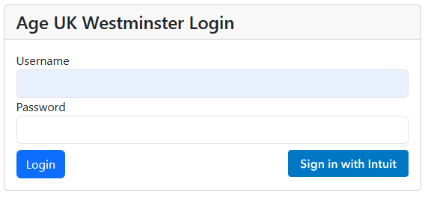

Figure , Login screen for aukw.org.uk

Pressing that button takes you to the QuickBooks website where you must enter your username and password (and any two-factor authentication challenge that is enabled) and then select either the charity or the Enterprises company from the dropdown. After selecting the company and pressing “Next” you will be taken back to the aukw.org.uk website and logged in.

The other way to make a connection to QuickBooks is via the Profile page. The user must be already logged in. In the top menu click on the small down arrow next to Account and then Profile. The QuickBooks Connections section is at the bottom of the resulting page.

## Usage

When you open the payroll component it automatically downloads the employee project allocations from QuickBooks.

NOT FINISHED

# Appendix One – Staff Costs note in Final Accounts

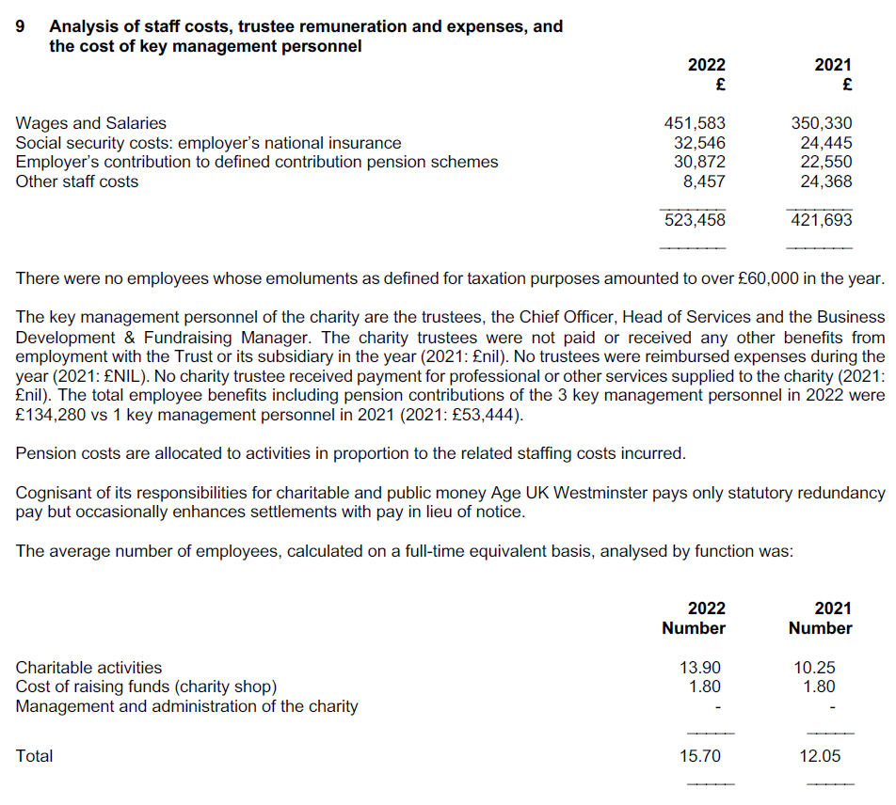

This is the note to the Age UK Westminster final accounts for 2021/22 showing a breakdown of staff costs.